All Saints Anglican Church
6904 Lougheed Highway, Agassiz, B.C. V0M 1A0
Bulletin February 2nd, 2026 – February 8th, 2026

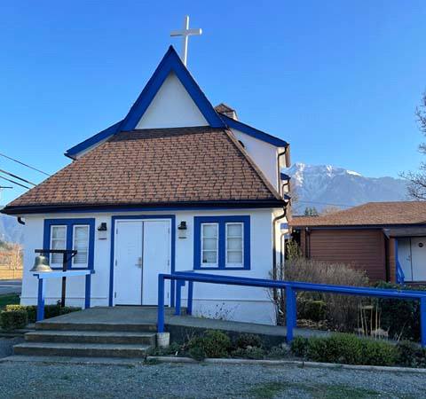

‘The ground we walk does not belong to us; for thousands of years it has been - and remains - the territory of the Stó:lō. We are grateful for their sharing.

Phone: 604-796-3553
Website: www.allsaints-agassiz.ca
https://www.facebook.com/groups/AllSaintsFamily
OUR DOOR IS OPEN AND ALL ARE WELCOME
February 8th, 2026, Fifth Sunday After Epiphany
Priest in Charge: The Reverend Philip Barker
Hosts: Graham Featherstone/Jennifer Pinlac
Intercessor: Sheila Barker
Lay Administrator: Dorothy Cresswell
Announcer: Virginia Jennings
Organ/Piano: Francesca Froehlich
Readers: Graham Featherstone/Dorothy Cresswell
Vicar’s cell phone: Revd. Philip Barker. 778-867-2461

Vicar’s Warden: Ginny Jennings. 604-796-2206
People’s Warden: Lynn Laughlin. 604-799-5131
Parish email: revpb1950@gmail.com
Please contact either warden if you have an issue that needs to be brought to the attention of the Vicar - or contact the Vicar direct (see above for details).

All Saint’s Calendar/Announcements:

- Book Club has chosen the next book, "Amazing Grace, the life of John Newton", by Bruce Hindmarsh and Craig Borlase. It's $24.99 as a paperback on Amazon and is also available on Kindle and as an audio book for free if you have an audio membership.
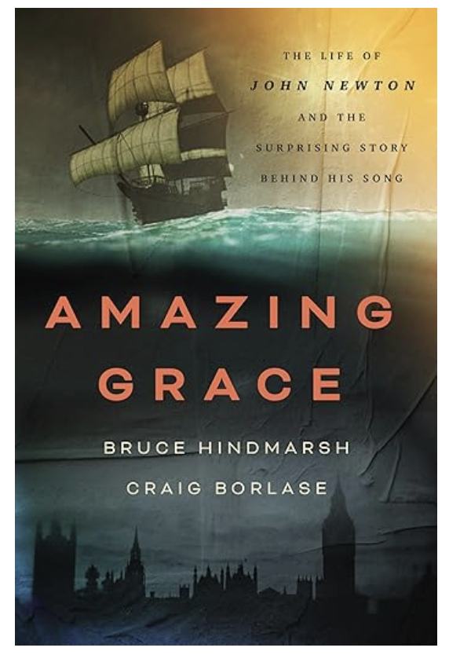

Our first meeting of the New Year will be on
Wednesday, January 14th, at 1700 (5.00pm) on Zoom.

Please let Sheila know at sjbarker0379@gmail.com
if you would like to join the group discussions or have
her order a copy of the book.

- Bible Study with Karol is every Saturday morning 0830-0900 on Zoom.

- Prayer Requests can be given on a piece of paper to either of the Wardens or the Vicar or entered in the Prayer Request Book on the lectern. Alternatively, you can contact Anthea Lewis at antheamlewis@shaw.ca for Pray First Prayer Circle, which is a confidential online prayer circle.

- Music Requests may be given to the Wardens or the Vicar.

- AA meets in the hall every Tuesday and Friday at noon.

- Every Thursday in the hall 1100-1200 we have a social time with coffee, games if you like or just talk.

- At 1000-1100 on Thursdays there is an Interactive Bible Study on the day’s Lectionary readings. All are welcome – discover the treasures in this amazing book!

- 5th Sunday of each month will be a potluck lunch after the service.

- Annual Vestry Meeting (AVM) on February 8th, 2026, after the service. Please be there if you are interested in the future of this church. Your involvement is vital to our success and survival.

Ministerial Meandering
Failure

Every morning I am faced with a daily reminder of my failure to pass my Honours viva in Surgery when I was a medical student. Fortunately, I made up for it later, but the memory of that day sticks in my memory like a stain I can never get rid of. I gave the wrong answer to a question that I actually did know the answer to - but got completely wrong in the heat of the moment.
It is an orange that recalls my error, as it is in the appearance of the skin, ‘peau d’orange’, which I suddenly and inexplicably said was an early marker of breast cancer - when I knew I was wrong - but for some insane reason decided to stick to my obstinate - and instantly failing - response.

Why such an event - over fifty years in my past - should cling to me with such ferocity, I have no idea. But I ask myself whether it is not because all of us need to be reminded at some point that we are not always right, and that we have, and will continue to make stupid mistakes. Clearly, it is not wise to persist in dwelling on past blunders, but a tick in the box of inclusion with the rest of fallen humanity is not a bad thing. There are some out there who need such a reminder.

We rarely learn lessons from our successes, but if we are open to the opportunity we can certainly learn from our failures. Those golden girls and boys who seem to live charmed lives with both ease of academic success and prowess on the sports field are all missing an essential ingredient in their make-up; Humility - in its literal sense; ‘humus’ means ‘earth’, and it is from that humble beginning that we arise - whether you claim to be an atheistic Darwinist or a fundamental Creationist. [I should just say that both these points of view are wrong. Darwin had his doubts and errors, and the fundamentalist flies in the face of both evidence and reason.]

It is possible that God needs us to make the odd botch of things, so that we can take a step back on the vertiginous ladder of hubris with which we might wish to storm his heaven. A reminder that we are creatures, formed in a miraculous way, and for a purpose that few of us ever truly learn - though our job is to try. As I quoted before from Mark Twain; ‘The two most important days of your life are the day you were born, and the day you find out why’.

Rudyard Kipling’s poem, ‘If’, has advice to give on most topics that pertain to acquiring maturity, and he says; ‘If you can meet with triumph and disaster, And treat those two imposters just the same;…’. The words imply not only how to approach such events in our lives, but that these events will come to pass in our lives. We will meet with success and failure - but we must not be overwhelmed by either. Too much success will always go to our heads; too much failure will give us cause for despair.

As I move towards the latter part of ‘middle age’, I rarely have to worry about taking and passing exams, but I count my successes and failures in much smaller - but equally satisfying terms. Can I safely boil a kettle and pour its steaming and dangerous contents into my tea mug without scalding myself, my wife, or my dog?
Perhaps I exaggerate for the sake of making the point - but more relevant might be my struggles with the internet, or some machine of torture my trainer directs me to in the gym, which threatens to turn me into some form of pretzel.

In summary, successes are fun - and not to be taken too seriously; after all, you were only an ace away from failure. And failures are what fashion you, and determine how you will grow up - if you ever do. Success may pat you on the back, but failure will - if you allow it - make you strong.

Philip+

Truth and Reconciliation
Thank you for the very positive response to the invitation to the current Table Talks series. I had to limit the numbers in the group because it is meant to be a series of small group conversations. Several people were disappointed, so I plan to run the series a second time, probably after Christmas.
Please let me know as soon as possible at sjbarker0379@gmail.com if you would like to join. Feel free to ask those taking part now for their feedback.

A Little Chuckle…

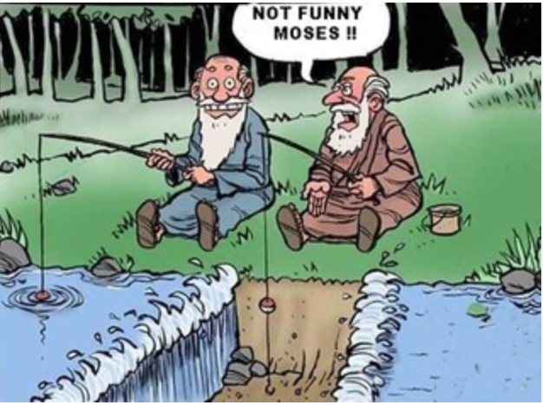

Birthdays this Month  February

Pat Misener – 2 Lyric George – 2
Liane Loeppky – 15 Wendy Pearson – 16
Bonnie Maitland – 26 Al Pinlac - 28

Diocesan Cycle of Prayer: We Pray for the Clergy and Congregation:

The Archdeaconry of Burrard; St. Margaret, Cedar Cottage, Vancouver - The Revd Heidi Brear ; St. Mark, Ocean Park - The Revd David Taylor

Anglican Church of Canada Cycle of Prayer – We Pray for:

The Rt. Rev. John Watton, Bishop, and the people and clergy of the Diocese of Central Newfoundland. For a growing openness to dialogue and encounter with people of other faith traditions during World Interfaith Harmony Week.

Collect

Merciful Lord, grant to your faithful people pardon and peace, that we may be cleansed from all our sins and serve you with a quiet mind; through Jesus Christ our Lord, who is alive and reigns with you and the Holy Spirit, one God, now and for ever.

Isaiah 58:1-12 Graham Featherstone

¹“Shout it aloud, do not hold back.
Raise your voice like a trumpet.
Declare to my people their rebellion
and to the descendants of Jacob their sins.
² For day after day they seek me out;
they seem eager to know my ways,
as if they were a nation that does what is right
and has not forsaken the commands of its God.
They ask me for just decisions
and seem eager for God to come near them.
³ ‘Why have we fasted,’ they say,
‘and you have not seen it?
Why have we humbled ourselves,
and you have not noticed?’

“Yet on the day of your fasting, you do as you please
and exploit all your workers.
⁴ Your fasting ends in quarreling and strife,
and in striking each other with wicked fists.
You cannot fast as you do today
and expect your voice to be heard on high.
⁵ Is this the kind of fast I have chosen,
only a day for people to humble themselves?
Is it only for bowing one’s head like a reed
and for lying in sackcloth and ashes?
Is that what you call a fast,
a day acceptable to the Lord?

⁶ “Is not this the kind of fasting I have chosen:
to loose the chains of injustice
and untie the cords of the yoke,
to set the oppressed free
and break every yoke?
⁷ Is it not to share your food with the hungry
and to provide the poor wanderer with shelter—
when you see the naked, to clothe them,
and not to turn away from your own flesh and blood?
⁸ Then your light will break forth like the dawn,
and your healing will quickly appear;
then your righteousness will go before you,
and the glory of the Lord will be your rear guard.
⁹ Then you will call, and the Lord will answer;
you will cry for help, and he will say: Here am I.

“If you do away with the yoke of oppression,
with the pointing finger and malicious talk,
¹⁰ and if you spend yourselves in behalf of the hungry
and satisfy the needs of the oppressed,
then your light will rise in the darkness,
and your night will become like the noonday.
¹¹ The Lord will guide you always;
he will satisfy your needs in a sun-scorched land
and will strengthen your frame.
You will be like a well-watered garden,
like a spring whose waters never fail.
¹² Your people will rebuild the ancient ruins
and will raise up the age-old foundations;
you will be called Repairer of Broken Walls,
Restorer of Streets with Dwellings.

Psalm 112:1-10

¹ Praise the Lord.
Blessed are those who fear the Lord,
who find great delight in his commands.

² Their children will be mighty in the land;
the generation of the upright will be blessed.
³ Wealth and riches are in their houses,
and their righteousness endures forever.
⁴ Even in darkness light dawns for the upright,
for those who are gracious and compassionate and righteous.
⁵ Good will come to those who are generous and lend freely,
who conduct their affairs with justice.

⁶ Surely the righteous will never be shaken;
they will be remembered forever.
⁷ They will have no fear of bad news;
their hearts are steadfast, trusting in the Lord.
⁸ Their hearts are secure, they will have no fear;
in the end they will look in triumph on their foes.
⁹ They have freely scattered their gifts to the poor,
their righteousness endures forever;
their horn will be lifted high in honor.

¹⁰ The wicked will see and be vexed,
they will gnash their teeth and waste away;
the longings of the wicked will come to nothing.

1 Corinthians 2:1-12 Dorothy Cresswell

¹ And so it was with me, brothers and sisters. When I came to you, I did not come with eloquence or human wisdom as I proclaimed to you the testimony about God. ² For I resolved to know nothing while I was with you except Jesus Christ and him crucified. ³ I came to you in weakness with great fear and trembling. ⁴ My message and my preaching were not with wise and persuasive words, but with a demonstration of the Spirit’s power, ⁵ so that your faith might not rest on human wisdom, but on God’s power.

⁶ We do, however, speak a message of wisdom among the mature, but not the wisdom of this age or of the rulers of this age, who are coming to nothing. ⁷ No, we declare God’s wisdom, a mystery that has been hidden and that God destined for our glory before time began. ⁸ None of the rulers of this age understood it, for if they had, they would not have crucified the Lord of glory. ⁹ However, as it is written:

“What no eye has seen,
what no ear has heard,
and what no human mind has conceived”—
the things God has prepared for those who love him—

¹⁰ these are the things God has revealed to us by his Spirit.

The Spirit searches all things, even the deep things of God. ¹¹ For who knows a person’s thoughts except their own spirit within them? In the same way no one knows the thoughts of God except the Spirit of God. ¹² What we have received is not the spirit of the world, but the Spirit who is from God, so that we may understand what God has freely given us.

Matthew 5:13-20 Vicar Philip Barker
¹³ “You are the salt of the earth. But if the salt loses its saltiness, how can it be made salty again? It is no longer good for anything, except to be thrown out and trampled underfoot.

¹⁴ “You are the light of the world. A town built on a hill cannot be hidden. ¹⁵ Neither do people light a lamp and put it under a bowl. Instead they put it on its stand, and it gives light to everyone in the house. ¹⁶ In the same way, let your light shine before others, that they may see your good deeds and glorify your Father in heaven.

¹⁷ “Do not think that I have come to abolish the Law or the Prophets; I have not come to abolish them but to fulfill them. ¹⁸ For truly I tell you, until heaven and earth disappear, not the smallest letter, not the least stroke of a pen, will by any means disappear from the Law until everything is accomplished. ¹⁹ Therefore anyone who sets aside one of the least of these commands and teaches others accordingly will be called least in the kingdom of heaven, but whoever practices and teaches these commands will be called great in the kingdom of heaven. ²⁰ For I tell you that unless your righteousness surpasses that of the Pharisees and the teachers of the law, you will certainly not enter the kingdom of heaven.

Odds and Ends

Pancake Sunday

February 15th after the service




Soup and Buns

Wednesdays from February 25th through April 1st

Volunteers are needed to bring soup for each Wednesday, and several volunteers are needed on April 1st, when All Saints is hosting.

Service is at 1800 (6:00pm) followed by soup and buns.

Please reach out to Ginny to sign up to bring soup.

